 __________________

**Teacher’s Initial**

**Set-1**

**Class Test No.: 02 Semester:**

**ID Number: Course Title:**

**Course Code: Date:**

Time: 30 mins Total Marks: 15

**PART A**

1. **Answer the questions within two sentence (2*2=4)**
   1. What is the difference between Web Server and Application Server?

Ans:

Web server is designed to serve HTTP content. Application server also support HTTP content along with different protocols and supports servlets.

Web server is designed to serve static content. Application server is designed to serve dynamic content.

Application server has web servers as integral part in them. But generally the opposite is not true.

* 1. Describe briefly about HTTP protocal.

**Ans:**

HTTP means HyperText Transport Protocol.

It is a simple request-response protocol layered on TCP/IP

1. Establish a TCP/IP connection, 2. Send a http GET request along connection and 3. Read from the connection the response from the web server

**PART B**

Suppose the Department of Software Engineering, DIU is organizing a study tour for the students of SWE Department, Main Campus. Students who have completed at least 15 credits are eligible to register for the tour. For that purpose, the department is planning to develop an online assessment system which will check if a student is eligible or not. In order for that the system will ask little information to the students, same as the diagram given below:

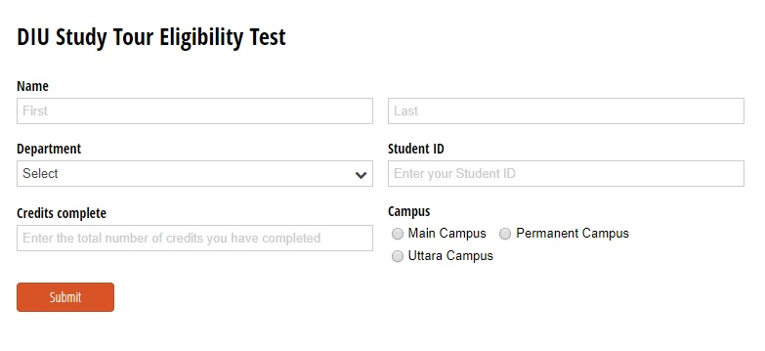

1. See the structure carefully and write the HTML and CSS **(6)**
2. Show that if a student doesn’t provide valid information to a field, there shows a warning message. **(3)**

**(For every <input> tag the required attribute and type must be written accurately)**

1. Using JS show pop-up: **(2)**
2. “Congratulations! You are eligible for the registration.”- To the students who meet the criteria.
3. “Unfortunately, you are not eligible for the registration.” - To the students who fail to meet the criteria.

**In HTML**

<form **name**=”myform”>

<input type=”text” **name**=”credit”>

or

<input type=”text” **id**=”crdt”>

**Code.js:**

function validateInfo(){

var credit = document.forms[“myform”][“credit”].value;

or

var credit = document.getElementById(“crdt”).value;

if(credit <15){

alert(“Unfortunate,you are not eligible”);

return false; //for document.form

}

else{

alert(“Congratulations, you are eligible ”);

return true; //for document.form

}

}

< button type=”submit” onclick=”return validateInfo()” value=”submit”>

//for document.form **return is needed**

**//for** document.getElementById return not needed